

Dhaka International University

Lab Report details:

**Lab Report Topic**: Design and Implementation of a Full Adder Using Logic Gates  
**Lab Report No** :04  
**Course Title** : Digital Logic Design Lab  
**Course Code** : 0713-204

|  |  |
| --- | --- |
| **Submitted By:** | **Submitted To:** |
| S M Nabil Ausaf  Roll: 01  Reg No : CS-D-91-23-124492 | Sumaiya Tabassum, Lecturer of CSE Department |

Date of Submission:25.06.25

**Experiment Title**

**Design and Implementation of a Full Adder Using Logic Gates**

**Objective**

To design, implement, and verify a **Full Adder** circuit using basic logic gates (AND, OR, XOR) and validate its output using a truth table.

**Introduction**

In digital electronics, a **Full Adder** is a combinational circuit that performs binary addition on **three inputs**:

* Two significant bits (**A** and **B**)
* One **carry-in (Cin)** from a previous stage.

It produces two outputs:

* **Sum (S)** – the result of the addition
* **Carry-out (Cout)** – the carry forwarded to the next addition stage.

Full adders are essential in designing arithmetic logic units (ALUs), calculators, and other digital computing circuits.

**Components Required**

| **Component** | **Quantity** |
| --- | --- |
| AND Gate IC (e.g., 7408) | 1 |
| OR Gate IC (e.g., 7432) | 1 |
| XOR Gate IC (e.g., 7486) | 1 |
| Breadboard | 1 |
| Power Supply (5V DC) | 1 |
| Connecting Wires | As needed |
| LEDs (for output display) | 2 |

**Theory**

**Boolean Equations:**

* **Sum (S):** S = A ⊕ B ⊕ Cin
* **Carry-out (Cout):** C = AB + BCin + ACin

These equations are derived from the binary addition rules.

**Logic Circuit Diagram**

* **Sum (S):**
  + First XOR gate: A ⊕ B
  + Second XOR gate: (A ⊕ B) ⊕ Cin
* **Carry (Cout):**
  + Three AND gates: A·B, B·Cin, A·Cin
  + One OR gate to combine all three: AB + BCin + ACin

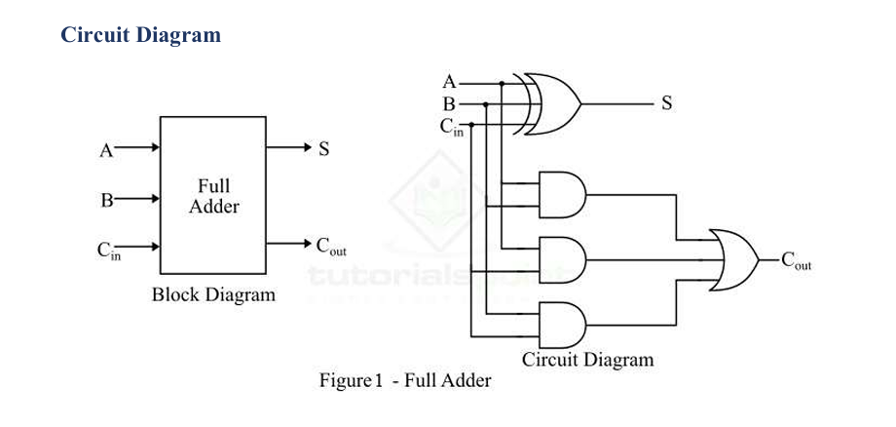

**Truth Table**

| **A** | **B** | **Cin** | **Sum (S)** | **Carry (Cout)** |
| --- | --- | --- | --- | --- |
| 0 | 0 | 0 | 0 | 0 |
| 0 | 0 | 1 | 1 | 0 |
| 0 | 1 | 0 | 1 | 0 |
| 0 | 1 | 1 | 0 | 1 |
| 1 | 0 | 0 | 1 | 0 |
| 1 | 0 | 1 | 0 | 1 |
| 1 | 1 | 0 | 0 | 1 |
| 1 | 1 | 1 | 1 | 1 |

**Procedure**

1. Place the ICs on the breadboard and connect the power supply (Vcc = +5V, GND = 0V).
2. Connect the input pins A, B, and Cin.
3. Wire the XOR, AND, and OR gates according to the logic circuit.
4. Connect LEDs to the outputs (Sum and Carry) through resistors.
5. Apply all 8 input combinations (000 to 111) and record the outputs.
6. Verify each output with the truth table.

**Observations**



| **A** | **B** | **Cin** | **Sum** | **Cout** | **Observed Correct?** |
| --- | --- | --- | --- | --- | --- |
| 0 | 0 | 0 | 0 | 0 | Yes |
| 0 | 0 | 1 | 1 | 0 | Yes |
| 0 | 1 | 0 | 1 | 0 | Yes |
| 0 | 1 | 1 | 0 | 1 | Yes |
| 1 | 0 | 0 | 1 | 0 | Yes |
| 1 | 0 | 1 | 0 | 1 | Yes |
| 1 | 1 | 0 | 0 | 1 | Yes |
| 1 | 1 | 1 | 1 | 1 | Yes |

**Result**

The Full Adder was designed and implemented successfully using basic logic gates. The observed outputs matched the expected results from the truth table.

**Conclusion**

The Full Adder circuit was verified both theoretically and practically. The experiment confirms that binary addition using logic gates follows predictable rules of digital logic and can be extended to multi-bit operations.

**Precautions**

* Ensure ICs are properly oriented (notch or dot on the left).
* Use current-limiting resistors for LEDs.
* Check connections carefully to avoid short circuits.
* Use clean and solid wiring to prevent loose connections.